**Module 3: Critical Thinking**

**Mobile App Prototype**

Ryan Thompson

Colorado State University - Global

CSC 505

Dr. Gonzalez

9 July 2024

**Synopsis**

For my shopping list prototype I opted for a simple single page design. An illustration of the shopping list app can be found in the page below. Everything needed for our basic shopping list app is located on a single page. There is clickable functionality to add and remove items while viewing the list. Since my prototype only has one page, I made a python script to showcase a demo of the shopping list. The script is terminal based and does not have the GUI built for it yet. To build the GUI, I would make use of Python’s [tkinter](https://docs.python.org/3/library/tkinter.html) package. However, the basic terminal based script showcases how the user can build and save their own shopping list.

| Shopping List   * Apples x * Bananas x * Computer x * *add new item(s)*  x   @ryan_thompson_2024 |
| --- |

*Shopping List Prototype Illustration*

*Simply click on the plus sign “****+****” and begin typing to add an item to the shopping list. If you wish to remove an item, click on the “x” next to the desired item.*

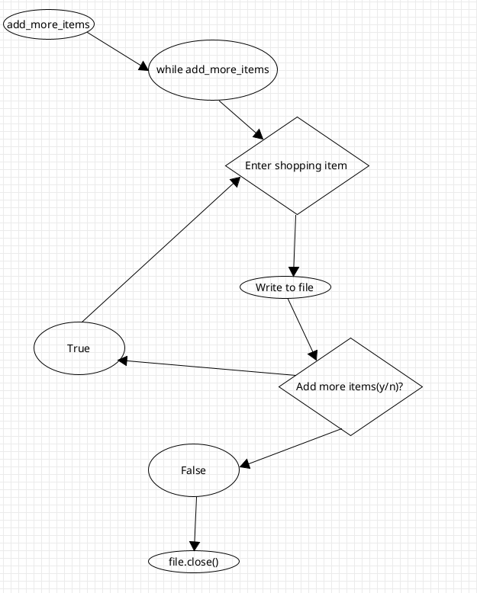

*Shopping List Prototype UML*

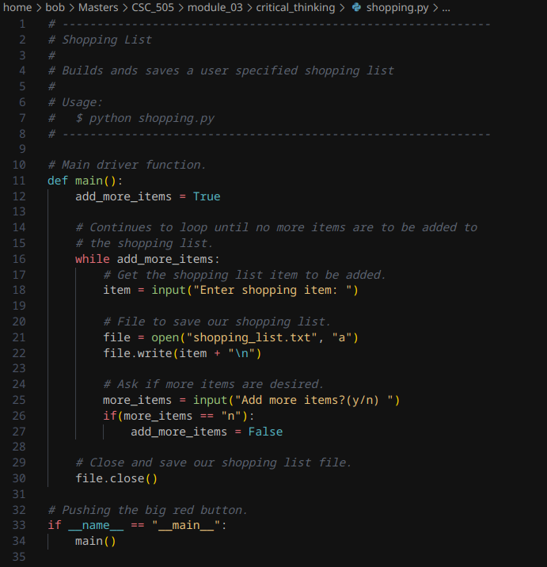

*Shopping List Prototype Script*

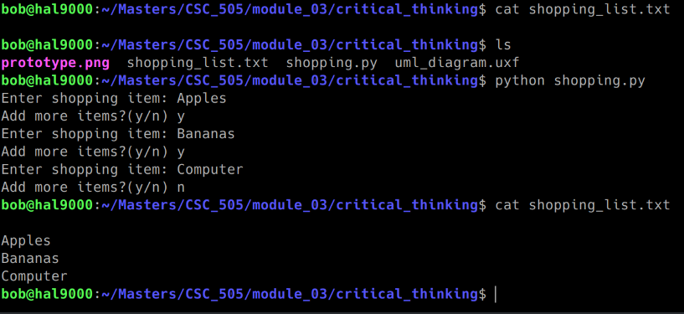

*Shopping List Prototype Script Demo Output*

**References**

GeeksforGeeks. (2021, August 23). Python: Maintaining grocery list. https://www.geeksforgeeks.org/python-maintaining-grocery-list/

Kondratowicz, P. (2023, June 5). Why use UML class diagrams?. Synergy Codes. https://synergycodes.com/blog/why-use-uml-class-diagrams/